**COSC 344 assignment 1**

**Group 5:**

Leader: Johnny Lee

Member: Mark Adam, Frank Zhao, Callum Grimmer, James Cross, Maxwell Jardine

1. **Mini-world description:**

For this assignment we chose to model a chain of retail bookstores as our mini world. The database keeps information on its customers, suppliers, inventory information, accounts and employees.

During our early group brainstorm sessions we encountered a challenge, in that, there were too many possibilities for expansion and our mini-world became rather complex very quickly. To reduce the complexity and fit it within the scope of this assignment, we chose to emphasise the user's perspective and select the entities based on what would be the most useful to the bookstore’s owner/management.

A brief summary of the aspects modelled in our assignment:

* The bookstore entity represents each store in the chain, we will keep information on the city, address, account and date opened for each store. We chose to model each bookstore’s address as a single attribute because, for our purpose of identifying the bookstore, splitting it further would be counterintuitive.
* Suppliers plays the key role of supplying books to the business. We will keep the business name and contact numbers, identifying each uniquely through their bank account number (in the unlikely event that multiple suppliers share the same name).
* Books are uniquely identified through ISBN, and are organised according to their title and author information.
* When a customer makes a transaction for books, employees take down the customer’s information, including: names, contact phone number, and delivery address. Each customer is also uniquely identified through a customer ID (in the event of returns, refunds, or loyalty discounts).
* Sales are organised into the form of a transaction, with books being sold to the customer, overseen by an employee. Each transaction contains the recorded information on the customer, employee, the date and time the order was made, as well as the transaction number. The transaction number uniquely identifies each transaction.
* Employee information is kept in the database, including their names, contact numbers, hourly rate, weekly hours and information on their qualifications. Employees are identified uniquely through their IRD number (NZ tax number). This is for the purpose of staff management, payroll and promotion.

**2. Entities and Attributes**

SUPPLIER

* Bank_Account_Number: simple, single-valued, integer, Key Attribute
* Company_Name: simple, single-valued, string
* Contact_number: simple, single-valued, integer

BOOKSTORE

* City: simple, single valued, string
* Address: simple, singled valued, string, Key Attribute
* Account: simple, singled valued, integer
* Date_opened: simple, single valued, date

BOOK

* Title: simple, single-valued, string
* ISBN: simple, single-valued, integer, Key Attribute
* Author: composite (FName, Middle_INIT, LName), single-valued, string
* Price: simple, single-valued, real
* Amount_In_Stock: simple, single-valued, integer

TRANSACTION

* Date: simple, single-valued, date
* Time: simple, single-valued, time
* Transaction_Number: simple, single-valued, integer, Key Attribute

EMPLOYEE

* Name: composite (FName, Middle_INIT, LName), single-valued, string
* IRD_Number: simple, single-valued, integer, Key Attribute
* Contact_Number: simple, single-valued, integer
* Weekly_Hours: simple, single-valued, real
* Hourly_Rate: simple, single-valued, real
* Wage: derived, single-valued, real

CUSTOMER

* Delivery_Address: composite(Street_Number, Street_Name, Suburb, City, Postcode), single-valued, string
* Customer_ID: simple, single-valued, integer, Key Attribute
* Name: composite (FName, LName), single-valued, string
* Phone_Number: simple, single-valued, integer

QUALIFICATIONS (Weak entity)

* Name: simple, single-valued, string, Weak Key Attribute
* Type: simple, multi-valued, string
* Date_Received: simple, single-valued, date
* Expiry_Date: simple, single-valued, date

**3. Relationships**

SUPPLIES

* M: N relationship.
* There are many different suppliers in the database, each supplier could supply multiple (types of) books.
* SUPPLIER is total participation; BOOK is total participation.

WORKS_FOR

* N:1 relationship
* An employee can only work for one bookstore, a bookstore can have many employees working for it.
* EMPLOYEE is total participation; BOOKSTORE is total participation.

OVERSEES

* M:N relationship.
* Multiple numbers of employees can oversee a multiple numbers of transactions to customers.
* Not every employee can oversee a transaction.
* EMPLOYEE has partial participation; TRANSACTION has total participation.

HAS

* 1:N relationship.
* One employee could have multiple qualifications, but not every employee has a qualification.
* Each qualification is identified through identifying the employee first.
* EMPLOYEE has partial participation; QUALIFICATION has total participation.

MAKES

* 1:N relationship.
* One customer can make multiple orders over time.
* Both TRANSACTION and CUSTOMER has total participation.

CONTAINS

* 1:N relationship
* One order can contain multiple numbers of books.
* BOOK has partial participation; TRANSACTION has total participation.

4. **ER diagram**

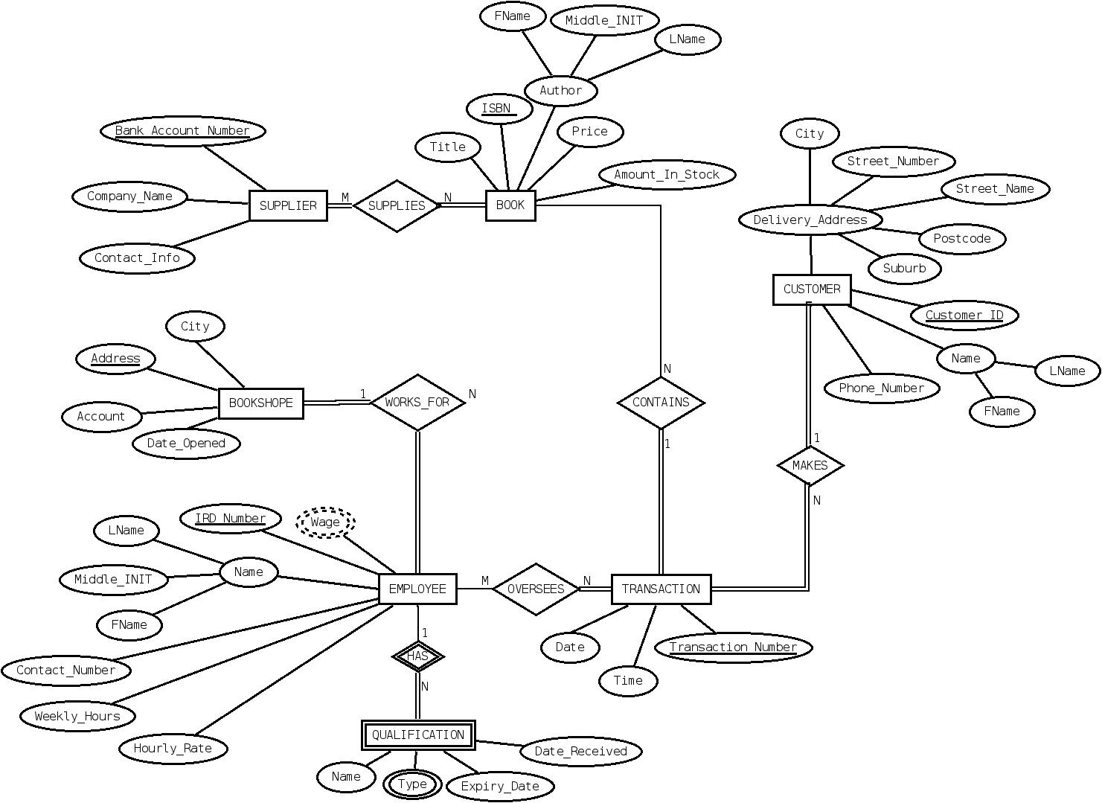

5. **Teamwork Summary**

Assignment work was divided equally and all team members contributed fairly. Regular meetings were held throughout the allotted time period and were well attended. Leadership and task delegation went smoothly. It was agreed by most that this was one of the better teams from everyone's current experience in computer science, partially due to be able to pick the team members at the beginning of the assignment.

The team is bigger than what is usually encountered for group assignments, which did lead to extended discussions and many differing opinions. This in turn lead to many differing ER diagrams models before final agreement.

Initially each individual worked on separate parts of the model with the intention to add each of their entities and relationships later, but this proved non-productive as ideas evolved. It was later found to be easier to work on the ERD while the group was together with one person entering adjusting the model while the other members could provide input and ideas. Once the main model was decided upon each member reviewed the ERD and made adjustments for other members scrutinize.